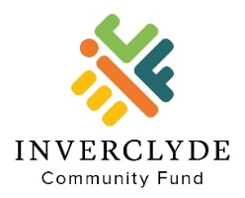

Sustainable Development Grants
Grant Application Form for Individuals

This application from is for individuals only

Please Read the Sustainable Development Grants Information and Guidance
before completing this form

Before completing the application form, you should have a discussion with one of our Trustees. Please call 01475 866140 to talk about the ideas you have for your project or activity.

To apply for a grant please complete this form and send it to us.

- Tell us about yourself

Name
Address
Home phone number
Mobile phone number
Email

What is your interest in Sustainable Development?

Where did you hear about the Sustainable Development Grants? (Please X)
Word of Mouth
Inverclyde Community Fund Website
Social Media (Facebook/Twitter/LinkedIn)
CVS Inverclyde
Local Press
Other, (please detail below)

- Tell us about your project / activity

Which sustainable development priorities does your project or activity address? (Please X all that are relevant) Your project must address at least 1.
The environment
Renewable energy
Energy efficiency
Sustainable Development - community or society
Sustainable Development - the economy
Sustainable development - culture

What would you like to do with the grant? Please describe your project or activity.
What difference will your project or activity make?
Why do you think it will make a difference?
Who or what will benefit from your project or activity?
What will the grant pay for? Please provide an estimate of all costs.
What is the total cost of your project or activity? | £
How much grant are you requesting from us? | £
When will your project or activity start?

When will your project or activity finish?

- Referees
Please provide the names and contact details of two independent referees who support this application. Each referee must be someone who knows you well in a professional capacity through your education, work, volunteering, hobbies, or faith.

Referee 1
Name
Position & organisation
(If appropriate)
Address

Telephone / mobile
E-Mail
In what capacity does this referee know you?

Referee 2
Name
Position & organisation
(If appropriate)
Address

Telephone / mobile
E-Mail
In what capacity does this referee know you?

- Declaration
In signing below:

- I confirm that the referees are aware of and support this application for a grant.
- I confirm that any grant awarded will only be spent as described in this application.
- I agree to complete an end of grant report when requested.
- I declare that I have not knowingly provided false or misleading information above.
- I’m happy to support promotion of the Inverclyde Community Fund should my application be successful.

Signature
Print Name
Position
Date

- Sending Your Application

Please send the following document by email to: apply@inverclydecommunityfund.org.

- Your completed application form in Word format. Please do not send the application form in PDF format

If you are unable to email your application and supporting documents, you can post or deliver them in person to:

Inverclyde Community Fund
c/o Inverclyde Community Hub
75-81 Cathcart Street
Greenock
PA15 1DE
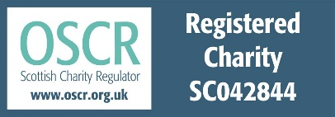
Tel: 01475 866140
Email enquiries: trustees@inverclydecommunityfund.org

